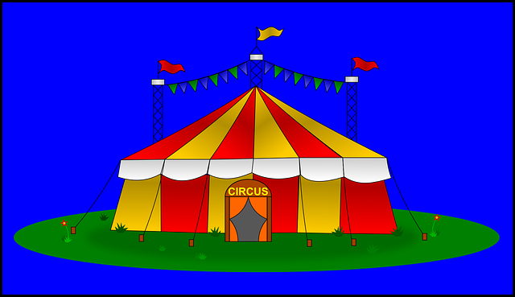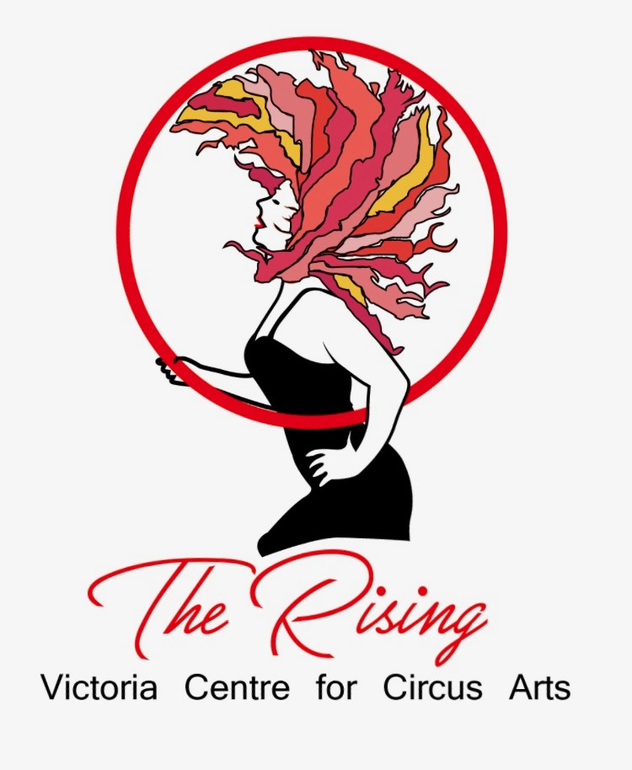

You’re Invited To a

CIRCUS Birthday Party!

***The Rising*** is the Westshore’s first circus school and company offering aerial and acrobatic circus classes from ages 2 yrs-adult. We also host workshops and parties, kids circus events and camps, and create circus shows performing at many private and corporate events.

***Special Discount for all party participants!***

For $10 off any Class Session or CirKids Nite In enter promo code: birthday10

** visit our website for all our exciting programs

www.therisingcircus.com

**What To Wear:**

* hair tied back
* bare feet
* no jewelry, zippers, metal fasteners
* athletic wear that you can move freely in
* no clothing that can flip over head and obstruct vision

**Parking:** 3 spots for customers directly infront of the school. If full, park in communal parking lot in front of Gescan

Aerial Silk, Hoop, Trapeze and More!!

**For:**

**Date:**

**Time:**

**RSVP:**

**Location:** The Rising- Victoria Centre for Circus Arts

Unit 140-1047 Langford Pkwy

Victoria, BC V9B 0A5

( between Princess Auto and Eagleridge Community Centre )

**Website:** [www.therisingcircus.com](http://www.therisingcircus.com)

**Tel:** 250-857-1785

**Waiver:**

* All participants must sign the online waiver in advance at:

**https://www.smartwaiver.com/v/therisingcircus/**